BSCS FINAL PROJECT
Requirements Specification

AssetIn: Asset Management Tool



Project Advisor

Sir.Asif Farooq

Presented by:
Group ID: F24BSCS042

Student Reg# | Student Name
L1F21BSCS1059 | MUHAMMAD BURHAN
L1F21BSCS0485 | AREEBA KHAN
L1F21BSCS0484 | NOOR-UL-AAIN MAQBOOL

Faculty of Information Technology

University of Central Punjab
Software Requirements Specification
Version 01
AssetIn:
Asset Management Tool
Advisor: Sir. Asif Farooq

Group F23BSCS042
Member Name | Primary Responsibility
MUHAMMAD BURHAN | Back-end & Database
AREEBA KHAN | UI/UX & Front-end integration
NOOR-UL-AAIN-MAQBOOL | UI/UX & Front-end designing

Table of Contents
Table of Contents i
Revision History ii
Abstract iii
1. Introduction and Background 1
1.1 Product (Problem Statement) 1
1.2 Background 1
1.3 Scope 2
1.4 Objective(s)/Aim(s)/Target(s) 2
1.5 Challenges 3
1.6 Learning Outcomes 3
1.7 Nature of End Product 3
1.8 Completeness Criteria 4
1.9 Business Goals 5
1.10 Related Work/ Literature Survey/ Literature Review 5
1.11 Document Conventions 5
2. Overall Description 6
2.1 Product Features 6
2.2 User Classes and Characteristics 7
2.3 Operating Environment 8
2.4 Design and Implementation Constraints 9
2.5 Assumptions and Dependencies 10
2.5.1 Assumptions 10
2.5.2 Dependencies 10
3. Functional Requirements 12
3.1 Track Asset Locations and Status 12
3.2 Access Dashboards and Manage Asset Categories 13
3.3 Request Asset and Repairs 14
3.4 Oversee Asset Management Tasks 15
3.5 Manage Fixed and Variable Assets 16
3.6 Schedule Maintenance for Assets 17
3.7 Receive Configurable Email Alerts 18
3.8 Utilize Barcode Scanning 19
3.9 Authenticate and Authorize via JWT 20
3.10 Vendor Registration and Management 21
3.11 Clone Asset Records or Configurations 22
3.12 Requirements Analysis and Modeling 23
4. Nonfunctional Requirements 33
4.1 Performance Requirements 33
4.2 Safety Requirements 34
4.3 Security Requirements 35
5. Revised Project Plan 37
Appendix A: Glossary 37
6. References 39
Appendix B: IV & V Report 40

Revision History
Name | Date | Reason For Changes | Version

Abstract
Asset management is crucial for organizations to maintain operational efficiency, yet many existing tools suffer from fragmented systems, poor usability, and limited scalability. These inefficiencies lead to increased costs, underutilization of assets, and difficulties in decision-making processes. Our project, AssetIn, aims to address these challenges by providing an intuitive, cloud-based asset management tool that integrates real-time data, vendor management, and predictive analytics.
Leveraging modern technologies such as Angular, .NET, and MySQL, the tool offers a comprehensive solution for tracking both fixed and variable assets, managing vendor relationships, and streamlining maintenance schedules. The tool also incorporates cloud storage for secure and scalable media handling, allowing organizations to store asset-related images, documents, and videos efficiently.
By addressing the shortcomings of existing tools such as Ralph3, SnipeIT, and Asset Tiger, AssetIn is expected to significantly improve asset management workflows. This solution will enhance user experience, optimize asset utilization, and reduce operational costs for organizations. Collaboration with Nextonix ensures industry-standard practices, and the final product will be tested in real-world scenarios to deliver a robust and practical asset management tool.

Introduction and Background
Effective asset management is a critical function for organizations aiming to optimize resources, reduce operational costs, and maintain long-term efficiency. Assets, including software licenses, development tools, intellectual property, and employee expertise, play a pivotal role in the functioning of any organization, particularly in the software industry. Despite the availability of several asset management tools, many organizations continue to face inefficiencies in tracking, maintaining, and utilizing their assets. These inefficiencies stem from overly complex systems, fragmented workflows, lack of real-time data integration, and limited customization options. The consequences include higher operational costs, underutilization of assets, and difficulties in making informed decisions.
Existing asset management solutions, such as Ralph3, SnipeIT, and Asset Tiger, provide specific functionalities but fail to deliver a comprehensive solution that balances usability, scalability, and efficiency. Ralph3, for example, is known for its robust features but is highly complex to install and configure, often requiring advanced technical knowledge. SnipeIT, while simplifying IT service management, lacks broader applicability for other types of assets and does not include vendor management features. Similarly, Asset Tiger offers ease of use but is not scalable for larger organizations. The fragmented nature of these systems hinders their effectiveness when applied across diverse organizational contexts.
AssetIn, our proposed solution, addresses these gaps by offering an intuitive, scalable, and cloud-based asset management tool that integrates multiple asset management functions into a single platform. Built using Angular, .NET, and MySQL, and leveraging cloud storage, AssetIn aims to provide a seamless experience for managing both fixed and variable assets. The tool will also incorporate predictive analytics, vendor management, and media handling features, ensuring organizations can optimize their asset utilization, streamline workflows, and make data-driven decisions.

The significance of this project lies in its potential to reduce the operational complexities faced by organizations in managing assets. By providing a user-centered, easy-to-use platform, AssetIn is set to enhance productivity, lower costs, and simplify asset management processes. The collaboration with Nextonix further ensures that the system adheres to industry standards, making it a practical and impactful solution for real-world applications.

Product (Problem Statement)
Organizations often face challenges in managing assets due to the complexity and limitations of existing tools. Current solutions lack essential features like real-time tracking, predictive analytics, and vendor management, resulting in fragmented workflows, underutilized resources, and higher operational costs. Additionally, the usability and scalability of these tools fail to meet the diverse needs of organizations, leading to low adoption rates.
AssetIn aims to solve these issues by providing a comprehensive, cloud-based solution that integrates all aspects of asset management into an intuitive and scalable platform. This system will reduce operational inefficiencies, enhance asset utilization, and support data-driven decision-making processes, ultimately simplifying asset management for businesses.

Background
Efficient asset management is essential for organizations to optimize resources, reduce operational costs, and ensure sustainable growth. Assets, ranging from physical resources to intellectual property and software licenses, form the backbone of operational efficiency. However, many organizations face challenges in managing these assets due to fragmented workflows, lack of real-time data integration, and limited customization options in existing tools.
Popular solutions like Ralph3, SnipeIT, and Asset Tiger address specific asset management needs but fall short in offering a holistic, scalable, and user-friendly approach. For instance, Ralph3 is feature-rich but overly complex to configure, SnipeIT simplifies IT asset management but lacks versatility for broader applications, and Asset Tiger, though easy to use, does not scale effectively for large organizations.
These shortcomings result in inefficiencies, including underutilization of assets, higher costs, and difficulties in making data-driven decisions. Recognizing this gap, the proposed solution, AssetIn, aims to deliver a comprehensive and intuitive cloud-based asset management tool. By integrating real-time tracking, vendor management, predictive analytics, and media handling capabilities, AssetIn seeks to streamline workflows, enhance decision-making, and optimize asset utilization across various industries.

Scope
AssetIn aims to develop a cloud-based asset management solution designed to address the limitations of current systems, providing organizations with a comprehensive platform for managing their assets. Key features include real-time tracking and monitoring of assets, with advanced search and filtering capabilities for quick access to critical data. The system also streamlines vendor management and procurement processes, facilitating vendor registration, maintenance, and sales management, all while ensuring smooth workflows throughout.
The platform will leverage predictive analytics to forecast maintenance needs, optimize asset usage, and generate actionable reports to support decision-making. Cloud storage integration will provide secure, scalable storage for managing documents, images, and videos related to assets. The user interface will be intuitive, offering dashboards for real-time monitoring and easy navigation, ensuring accessibility for different user roles, including organization owners, asset managers, and vendors.
AssetIn will be built on a robust MySQL database with secure, normalized structures to support scalability as the system grows. It will incorporate strong authentication mechanisms like JWT to safeguard user data and ensure role-based access controls. Extensive testing and quality assurance processes will validate the system's functionality and performance, ensuring the platform adapts to the needs of small, medium, and large organizations without compromising efficiency or reliability. By combining these features, AssetIn will streamline asset management workflows, reduce operational costs, and offer organizations a scalable, efficient solution for managing their assets.

Objective(s)/Aim(s)/Target(s)
The AssetIn project aims to develop a scalable and user-friendly asset management tool to improve operational efficiency and address the limitations of existing solutions. Key objectives include:
- User-Friendly Interface: Design an intuitive platform for organization owners and asset managers to efficiently track, maintain, and manage both fixed and variable assets.
- Real-Time Asset Tracking and Vendor Management: Implement real-time tracking of asset location, condition, and usage, while integrating vendor management for streamlined procurement, repairs, and sales.
- Predictive Analytics and Cloud Storage: Utilize data-driven insights for asset optimization and lifecycle management, and provide secure cloud-based storage for asset-related media.
- Scalability and Security: Build a scalable system with strong security features like JWT authentication to support growing asset and user volumes while ensuring data protection.

Challenges
The development of AssetIn involves several complex tasks that require deep understanding of technologies, problem-solving skills, and adaptability. Key challenges include:
- Scalability of Database Design: Ensuring the MySQL database remains scalable and optimized as requirements evolve, while maintaining performance and flexibility.
- Implementation of Predictive Analytics: Developing predictive models for asset optimization and integrating them with user-friendly reporting mechanisms.
- Ensuring Security and Data Protection: Implementing robust security measures, including JWT for authentication, to protect sensitive data in a cloud environment.
- Performance Optimization: Optimizing the system’s performance as it scales, ensuring efficient handling of increasing assets, users, and media files.
- User Experience (UX) Design: Creating an intuitive interface that supports multiple user roles without compromising usability in complex asset management workflows.
These challenges will require significant technical expertise and iterative problem-solving to ensure that the AssetIn system is robust, scalable, and user-friendly.

Learning Outcomes
Upon successful completion of the AssetIn project, students will gain valuable skills and knowledge across several key areas of computer science and software development. The specific learning outcomes include:
- Proficiency in Full-Stack Development:
  - Students will develop skills in frontend (Angular) and backend (.NET Core), building a scalable, real-time web application with integrated MySQL databases and cloud storage.
  - They will implement APIs, apply predictive analytics, and ensure data security using JWT.
  - Experience in UI/UX design for user-friendly interfaces and using JIRA for Agile project management.
- Deployment:
- Students will learn the deployment process, optimizing performance and ensuring smooth operation in real-world environments.

Nature of End Product
The AssetIn project will deliver a comprehensive asset management tool with the following key features:
- Real-Time Asset Tracking: Track asset location, condition, and status in real time for better decision-making and operational efficiency.
- Predictive Analytics: Use data-driven insights to forecast maintenance needs and optimize asset performance, reducing downtime and underutilization.
- Integrated Vendor Management: Streamline procurement, repairs, and asset sales within a unified platform.
- Scalability and Security: Ensure scalable performance to manage growing assets and users, with secure authentication using JWT for data protection.

Completeness Criteria
Here is a proposed completeness criteria table for AssetIn, based on the key components of your project. Each subpart is defined, with assigned weightage to reflect the importance of each feature in evaluating the project’s success:

 | Criteria | Weightage %
1 | User Interface Design (Web GUI): Develop an intuitive, user-friendly interface for organization owners, asset managers, and vendors to easily manage and track assets. This will include real-time dashboards and essential navigation for core functionalities. | 15
2 | Real-Time Asset Tracking and Monitoring: Implementation of real-time tracking to monitor asset locations, status (assigned, in stock, damaged), and maintenance schedules, with advanced search and filter options. | 15
3 | Vendor and Procurement Management: Integration of vendor-related functionalities, allowing users to manage procurement, repairs, sales, and vendor registrations in a seamless manner. | 10
4 | Cloud Storage Integration: Securely manage asset-related media (documents, images, videos) through cloud storage solutions, ensuring scalability and accessibility of data. | 10
5 | Predictive Analytics and Reporting: Develop and implement predictive analytics for maintenance scheduling and asset performance optimization, as well as generating comprehensive reports for decision-making. | 15
6 | Database Design and Iterative Development: Ongoing design and adjustments of the database schema (using MySQL) to accommodate new requirements during the development process. The database design will be flexible and scalable, ensuring normalization, security, and efficiency throughout all phases of development. | 20
7 | Security and Authentication: Ensure robust security features such as JWT-based authentication and authorization to protect user data and asset information, especially in cloud storage environments. | 5
8 | Testing: Comprehensive functional and non-functional testing to ensure the system works effectively in real-world environments. | 10

Total: 100%
This breakdown provides a clear structure for the evaluation of your project, with appropriate weightage for each critical component.

Business Goals
- Optimized Asset Utilization: Track asset conditions and usage in real time to ensure efficient utilization and minimize wastage.
- Cost Efficiency: Reduce operational costs through predictive maintenance, efficient asset tracking, and streamlined vendor management, leading to lower procurement and asset replacement costs.
- Data-Driven Decision-Making: Leverage predictive analytics to make informed decisions on asset lifecycle, procurement, and maintenance.
- Streamlined Workflows: Integrate asset tracking, vendor management, and maintenance scheduling into a unified platform to enhance workflow efficiency.
- Scalability and Security: Ensure the system can scale with organizational growth while maintaining robust security with JWT authentication for data protection.
- Vendor and Compliance Management: Improve vendor relationships and ensure compliance by centralizing vendor data and maintaining secure asset transaction records.
- Operational Efficiency and Sustainability: Automate processes to reduce manual errors, improve productivity, and promote sustainability through optimized asset usage and reduced carbon footprint.

Related Work/ Literature Survey/ Literature Review
Asset management tools have been widely studied and developed, with a focus on improving usability, scalability, and performance. Several solutions already exist in the market, each addressing specific organizational needs. However, most existing tools suffer from complexity, limited scalability, or fragmented functionalities. This literature review explores popular asset management tools like:
- Ralph3
- Snipe-IT
- Asset Tiger
While existing asset management tools like Ralph3, Snipe-IT, and Asset Tiger address certain aspects of asset tracking, they often fall short in providing a comprehensive, scalable, and user-friendly solution. AssetIn aims to fill this gap by offering a holistic asset management system that integrates real-time tracking, vendor management, predictive analytics, and cloud storage into one powerful and easy-to-use platform. Through this, AssetIn will streamline asset management workflows and improve decision-making processes for organizations across various industries.

Document Conventions
This Software Requirements Specification (SRS) follows these conventions for clarity and consistency:
- Font Style: Times New Roman, 12pt for body text and 14pt bold for headings. Section titles are bold, and subsections are bold-italic.
- Font Color: Standard black text with key terms highlighted in bold for emphasis.
- Lists: Bullet points and numbered lists are used to simplify complex information.
- Tables: Tables are formatted for clarity with bold headers and minimal borders.
- Acronyms/Abbreviations: Defined upon first use (e.g., AssetIn as Asset Management Tool).
- Technical Terms: Standard casing for software-related terms (e.g., Angular, .NET Core, MySQL).
- Layout: Numbered sections and subsections, with an automatically updated table of contents.
- References: External sources are cited in the References section using appropriate academic citation formats.

Overall Description

Product Features
AssetIn is a cloud-based asset management tool designed to simplify asset tracking, management, and maintenance. Key features include:
User and Organization Owner Panels: The User Panel allows asset purchase, repair, and transfer requests, while the Organization Owner Panel manages asset categories, user approvals, vendor interactions, and asset-related transactions.
Asset Manager Panel: Enables asset managers to update statuses, track locations, and handle tasks efficiently through an intuitive dashboard.
Vendor Dashboard: Provides organization owners with tools for managing vendor registrations and transactions related to asset sales, maintenance, and purchases.
Asset Tracking and Maintenance Scheduling: Real-time asset tracking monitors asset status, location, and condition, while maintenance scheduling ensures timely servicing to prevent downtime.
Cloud-Based Storage Integration: Secure cloud storage for storing and retrieving asset-related media (documents, images, videos), ensuring accessibility and protection.
Advanced Search and Filters: Enhanced search options allow users to quickly find and manage assets, improving efficiency in asset tracking and reporting.
Email Alerts: Configurable email notifications keep users informed about maintenance schedules, asset transfers, or status changes.
Barcode Scanning: Barcode scanning streamlines asset management by enabling quick, accurate tracking of assets.
Cloning Entity Feature: Allows users to duplicate asset records or configurations, saving time during bulk asset addition or category setup.
API Authentication and Security: Secure API access via JWT authentication protects sensitive data and ensures authorized interactions with the system.
Scalability and Adaptability: Designed to scale with growing organizations, the system supports future extensions like a Super Admin dashboard without compromising performance or security.
AssetIn combines these features to deliver a comprehensive, scalable, and secure asset management solution, enhancing workflows, reducing costs, and supporting data-driven decisions across various organizations.

User Classes and Characteristics
Organization Owner (Primary User Class)

- Frequency of Use: High (daily or multiple times per week)
- Key Functions Used:
  - Overseeing asset management tasks and categories.
  - Managing user roles, permissions, and asset-related requests. Handling vendor registration, sales, and maintenance.
  - Monitoring asset performance and generating reports.
  - Overseeing maintenance scheduling.
- Technical Expertise: Medium to High
- Security/Privilege Levels: Highest (full system access and admin rights)
- Educational Level: Varies (business owners or senior management with basic to intermediate technical knowledge)
- Characteristics:
  - Organization Owners have the broadest level of access and control.
  - They are responsible for strategic decision-making and approving financial or maintenance-related actions.
  - They require a comprehensive view of the organization’s asset data, reports, and vendor activities, but may not need to be deeply involved in day-to-day operational tasks.

Asset Manager (Primary User Class)

- Frequency of Use: High (daily or multiple times per week)
- Key Functions Used:
  - Managing fixed and variable assets.
  - Performing asset status updates.
  - Handling tasks related to asset location tracking.
  - Scheduling and tracking maintenance.
  - Generating reports on asset conditions and usage.
- Technical Expertise: Medium (intermediate technical expertise required for asset tracking and maintenance processes)
- Security/Privilege Levels: Medium (can access asset-related data but cannot manage users or vendors)
- Educational Level: Likely holds a position in operations or asset management with practical knowledge in asset tracking.
- Characteristics:
  - Asset Managers are responsible for the day-to-day management of assets.
  - They use the system to update asset statuses, track locations, and schedule maintenance.
  - They may need a clear and easy-to-navigate dashboard to manage asset information efficiently.

Vendor (Primary User Class)

- Frequency of Use: Medium (dependent on the frequency of asset-related transactions)
- Key Functions Used:
  - Registering for asset-related transactions (sales, maintenance, and procurement).
  - Interacting with the organization’s asset management team for asset servicing.
  - Viewing and responding to asset requests.
- Technical Expertise: Low to Medium (depends on the vendor's technical background, but primarily requires basic access to interact with the system)
- Security/Privilege Levels: Low (restricted to asset transactions and communication with the organization owner)
- Educational Level: Varies (likely basic technical knowledge or none needed, depending on the nature of the vendor interaction)
- Characteristics:
  - Vendors interact with the system mostly to manage their transactions and provide services for the organization’s assets.
  - They do not require full access to asset management functions, only those related to the sale, maintenance, or purchase of assets.
End Users (Secondary User Class)

- Frequency of Use: Medium to Low (depending on the frequency of asset requests)
- Key Functions Used:
  - Requesting asset purchases, repairs, or transfers through the User Request Panel.
  - Monitoring the status of their requested assets or pending actions.
- Technical Expertise: Low (basic user interface interactions for requesting assets)
- Security/Privilege Levels: Low (only limited access to asset requests and personal tracking data)
- Educational Level: Varies (general staff or employees with minimal technical skills)
- Characteristics:
  - These users interact with the system to request assets or check the status of their requests.
  - They are not involved in managing or tracking assets directly but rely on the system to track their asset-related requests.
System Admin (Technical User Class)

- Frequency of Use: Low to Medium (when system configurations, backups, or updates are required)
- Key Functions Used:
  - Performing system maintenance, such as data backups and updates.
  - Handling system configurations and ensuring smooth operation of the application.
  - Monitoring system performance and addressing any technical issues.
- Technical Expertise: High (requires a deep understanding of the software infrastructure)
- Security/Privilege Levels: High (full access to system configurations and server settings)
- Educational Level: Likely technical, with expertise in software or IT systems.
- Characteristics:
  - System Admins are responsible for the technical upkeep of the system and ensuring that it operates smoothly.
  - Their involvement is primarily in the background and less frequent than the main user classes.

Operating Environment
Hardware Requirements
For successful development and deployment of AssetIn, the following hardware is needed. Three laptops with:
- Multi-core processor (Intel i5 or equivalent) for development and testing.
- Minimum 8 GB RAM (16 GB recommended for better multitasking and performance).
- At least 256 GB SSD for storing software, frameworks, and local databases.
- Compatible OS: Windows 10+, macOS 10.12+, or Linux (e.g., Ubuntu).
Barcode Scanner
A scanner for testing barcode functionality, supporting USB or wireless connectivity. Must be compatible with supported barcode formats and offer fast, accurate scanning for smooth asset tracking integration.
These resources ensure a stable and efficient development environment for AssetIn.
Software and Application Components
- Nginx or Apache for handling HTTP requests and serving frontend/backend components.
- ASP.NET Core for scalable, secure request handling and database interactions.
- Angular 18 for a dynamic, responsive user interface.
- MySQL 8.0+ for storing asset, user, and vendor data, hosted locally or on cloud platforms (e.g., AWS RDS, Azure SQL).
- Cloudinary or similar for secure, scalable asset media storage.
- JWT for secure user authentication and data protection.
- Git & GitHub for collaborative development and version management.
- SMTP for sending alerts and notifications.
- RESTful APIs for system and external integrations.

API Testing Tools:

- Postman will be used for comprehensive API testing, allowing developers and testers to create and execute requests to verify API functionality. This tool will ensure the integrity and security of the APIs used in AssetIn by testing different API endpoints, request types, and payloads. It supports automated tests and offers robust testing features, including data validation and response assertion.
- Sawger will also be used for API testing, especially focusing on load testing and performance benchmarking. It will help test the system’s ability to handle a high volume of simultaneous requests and ensure that AssetIn can perform efficiently under heavy usage scenarios.

Interoperability with Other Systems
AssetIn will need to coexist with vendor systems for asset purchase and maintenance, allowing vendors to interact with the platform for sales, repairs, and procurement processes.
APIs will be designed for seamless communication between AssetIn and third-party vendor management platforms.
Barcode Scanning Devices:
AssetIn will support external barcode scanning hardware (USB or wireless scanners) to help with efficient asset tracking. The software will interface with these devices to quickly register and update asset statuses.
Cloud Integration:
AssetIn will be hosted in a cloud environment (e.g., Amazon Web Services (AWS), Microsoft Azure, or Google Cloud), ensuring high availability, scalability, and data redundancy. The cloud platform will also be used for handling increased loads and maintaining the system's performance over time.
Software Dependencies:
- Node.js (for frontend build processes and backend communication)
- Microsoft .NET Core SDK (for the backend environment)
- MySQL Client (for interacting with the database)
- Angular CLI (for frontend development)

Design and Implementation Constraints
Hardware Limitations
The developers are restricted to using laptops with decent but limited hardware specifications (e.g., multi-core processors, 8–16 GB of RAM). This limits the ability to simulate large-scale, high-performance scenarios during local testing.
Interfaces to Other Applications
The system must integrate seamlessly with third-party vendor platforms for procurement, maintenance, and asset sales. This will require the development of APIs to communicate effectively with these systems.
Authentication Protocols
JWT is the mandated authentication method, requiring strict adherence to its implementation for user security and API authorization.
Design Conventions and Standards
- Coding Standards:
Developers must follow best practices in C# and TypeScript for the backend and frontend, respectively, adhering to consistent coding conventions and patterns.
- User Experience Guidelines:
The UI/UX must be designed to align with accessibility standards (e.g., WCAG 2.1), ensuring ease of use for all users, regardless of technical expertise.

Budget and Resources:
Development is limited by a fixed budget, which restricts the use of premium tools, services, or additional hardware resources.

Assumptions and Dependencies

Assumptions
- Cloud Integration and Infrastructure:
  - The selected cloud storage provider (e.g., Cloudinary) is assumed to meet the system's needs for storing and retrieving media files (images, videos, documents) within usage limits and budget constraints. The provider's API is expected to remain stable and well-documented throughout the project lifecycle.
  - Development and production environments will have adequate resources, including laptops with compatible barcode scanners for testing, and servers with sufficient processing power, memory, and storage for managing asset data and user requests.
- Development and Usage Conditions:
  - All required tools and technologies (e.g., Angular, ASP.NET Core, MySQL, Postman, Swagger) will be available in stable, compatible versions, with no major version changes or deprecations during the development lifecycle.
  - Users, including organization owners and asset managers, are assumed to have reliable internet access for seamless interaction with the platform. Initial usage will primarily target small to medium-sized organizations, with scalability needs increasing progressively over time.

Dependencies
- Third-Party Services and Tools:
  - The system relies on Cloudinary (or a similar service) for media storage, and any disruptions, service outages, or API changes could impact functionality. Similarly, tools like Postman and Swagger are critical for API testing and validation, and any limitations or unavailability could delay the development process.
  - Reusable software components (e.g., JWT for authentication, Angular CLI) are assumed to function reliably without major bugs or compatibility issues.
- Resource and Network Stability:
  - The stability of the development environment (IDEs, version control systems like Git, and CI/CD pipelines) and hosting infrastructure (e.g., AWS, Azure, or Google Cloud) is crucial. Any disruptions could affect timelines or performance.
  - The project assumes consistent team availability with no significant turnover or skill gaps, as well as stable and secure network connections for both development and deployment, ensuring the reliability of real-time features like asset tracking.

Risks if Assumptions Are Incorrect
- If the selected cloud storage provider experiences outages, performance issues, or fails to meet the system's requirements, media storage and retrieval functionality may be disrupted.
- If the system encounters larger-than-anticipated data volumes, it could lead to degraded performance, delayed processing, or challenges in scaling infrastructure effectively.
- Changes in data privacy or security regulations may require significant rework to ensure compliance, potentially delaying project timelines or increasing costs.
- If essential tools (e.g., Postman, Swagger) are deprecated, discontinued, or become unavailable, it could disrupt API testing and validation processes, causing delays in development.

Functional Requirements

Track Asset Locations and Status
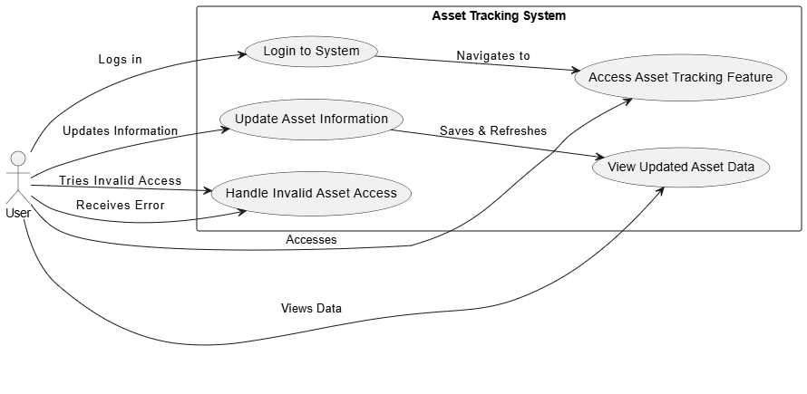
Identifier |  | UC-1
Purpose |  | Allow users to track the location and status of assets to ensure accurate record-keeping and monitoring.
Priority |  | High
Pre-conditions |  | - User must be logged in with appropriate permissions.  - Assets must already exist in the database.
Post-conditions |  | - Asset location and status are updated and accessible to authorized users.
Typical Course of Action
S# | Actor Action |  | System Response
1 | User logs into the system. |  | The system authenticates the user and displays the dashboard.
2 | User accesses the asset tracking feature. |  | System displays asset details, including location and status.
3 | User updates asset information (if required). |  | System validates input and updates the asset record.
4 | User views updated data. |  | System refreshes and displays updated information in real-time.
Alternate Course of Action
S# | Actor Action |  | System Response
1 | User attempts to access an invalid or non-existent asset. |  | System displays a "No Results Found" message.
Table 1: UC-1
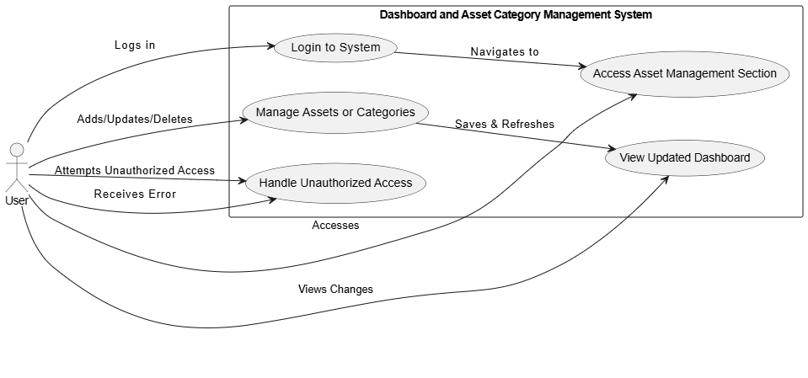

Access Dashboards and Manage Asset Categories

Identifier |  | UC-2
Purpose |  | Allow users to access dashboards and manage asset categories effectively.
Priority |  | High
Pre-conditions |  | - User must be authenticated and authorized to manage assets or categories.
Post-conditions |  | - Changes to assets or categories are saved and reflected on the dashboard.
Typical Course of Action
S# | Actor Action |  | System Response
1 | User logs into the system. |  | The system authenticates the user and displays the dashboard.
2 | User accesses the asset management section. |  | System displays options to manage assets or categories.
3 | User adds, updates, or deletes assets or categories. |  | System validates inputs and updates the database.
4 | User views updated dashboard. |  | System refreshes and displays the changes made.
Alternate Course of Action
S# | Actor Action |  | System Response
1 | User attempts to access without proper authorization. |  | System denies access and displays an error message.

Request Asset and Repairs

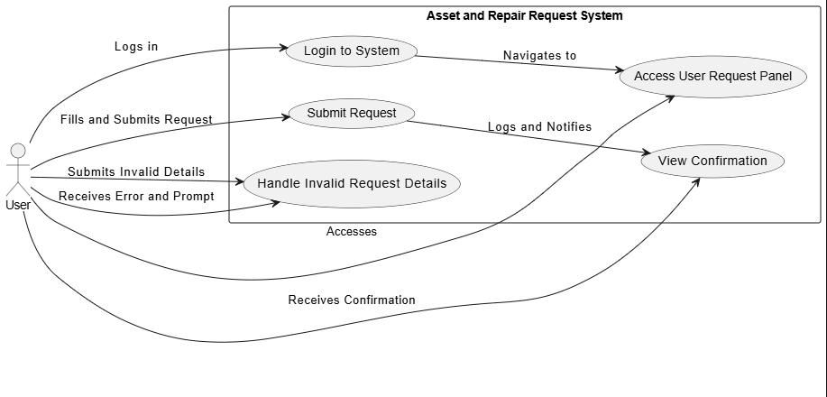
Identifier |  | UC-3
Purpose |  | Allow users to submit requests for asset and repairs.
Priority |  | High
Pre-conditions |  | - User must be logged in and authorized to submit requests.
Post-conditions |  | - Request is logged and routed to the appropriate manager for review.
Typical Course of Action
S# | Actor Action |  | System Response
1 | User logs into the system. |  | The system authenticates the user and displays the dashboard.
2 | User accesses the User Request Panel. |  | System displays options to request asset, and repairs.
3 | User fills in request details and submits. |  | System validates input and logs the request.
4 | User views confirmation. |  | System sends the request to the relevant manager and notifies the user.
Alternate Course of Action
S# | Actor Action |  | System Response
1 | User submits incomplete or invalid details. |  | System displays an error and prompts the user to correct the input.

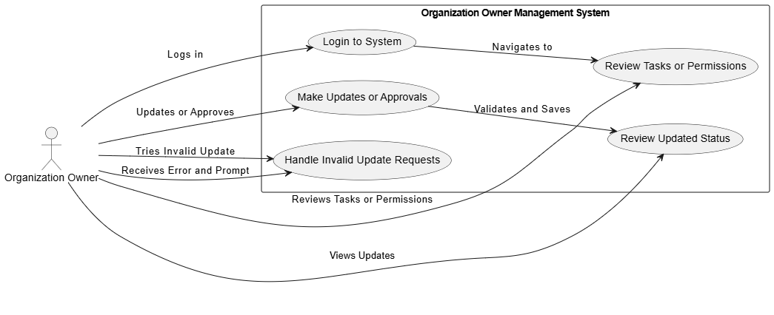
Oversee Asset Management Tasks

Identifier |  | UC-4
Purpose |  | Allow organization owners to oversee all asset management tasks, including user management and approvals.
Priority |  | High
Pre-conditions |  | - User must be logged in as an organization owner.
Post-conditions |  | - Updates to user permissions or request statuses are saved and reflected in the system.
Typical Course of Action
S# | Actor Action |  | System Response
1 | Organization owner logs in. |  | System authenticates the user and displays the Organization Owner Panel.
2 | Owner reviews tasks or permissions. |  | System displays pending requests, user permissions, or asset categories.
3 | Owner makes updates or approvals. |  | System validates changes and updates the database.
4 | Owner reviews updated status. |  | System reflects the changes and sends relevant notifications.
Alternate Course of Action
S# | Actor Action |  | System Response
1 | Owner tries to update an invalid request. |  | System displays an error and prevents the action.

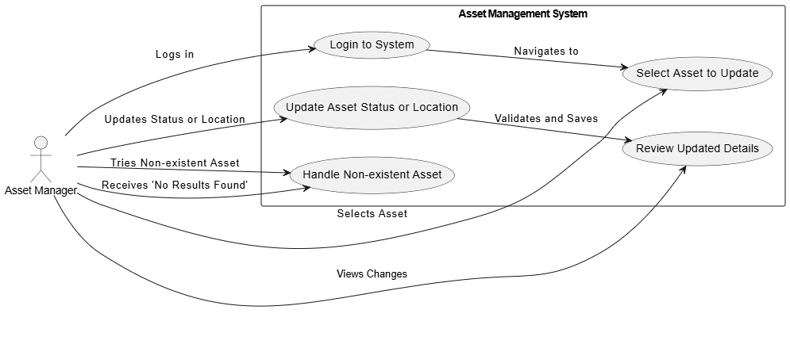
Manage Fixed and Variable Assets

Identifier |  | UC-5
Purpose |  | Allow asset managers to update statuses and manage fixed or variable assets.
Priority |  | High
Pre-conditions |  | - User must be logged in as an asset manager.
Post-conditions |  | - Asset updates are reflected in real-time in the system.
Typical Course of Action
S# | Actor Action |  | System Response
1 | Asset manager logs in. |  | System authenticates the user and displays the Asset Manager Panel.
2 | Manager selects an asset to update. |  | System displays asset details and current status.
3 | Manager updates the status or location. |  | System validates the input and updates the asset record.
4 | Manager reviews changes. |  | System refreshes and displays updated details in real-time.
Alternate Course of Action
S# | Actor Action |  | System Response
1 | Manager tries to update a non-existent asset. |  | System displays a "No Results Found" message.

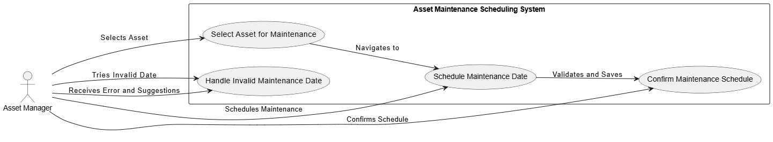
Schedule Maintenance for Assets

Identifier |  | UC-6
Purpose |  | Allow asset managers to schedule asset maintenance and prevent downtime.
Priority |  | Medium
Pre-conditions |  | - User must be logged in as an asset manager.
Post-conditions |  | - Maintenance schedules are saved, and notifications are sent to stakeholders.
Typical Course of Action
S# | Actor Action |  | System Response
1 | Asset manager selects assets for maintenance. |  | System displays asset details and maintenance history.
2 | Manager schedules a maintenance date. |  | System validates the input and saves the schedule.
3 | Manager confirms the schedule. |  | System sends notifications for upcoming maintenance.
Alternate Course of Action
S# | Actor Action |  | System Response
1 | Manager tries to schedule maintenance for an invalid date. |  | System displays an error and suggests available slots.

Receive Configurable Email Alerts
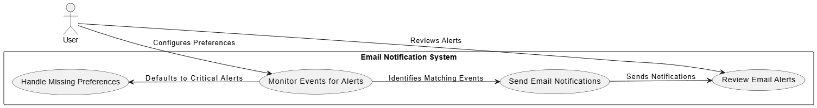

Identifier |  | UC-7
Purpose |  | Notify users of important events, such as maintenance schedules, asset transfers, or status changes, through email alerts.
Priority |  | Medium
Pre-conditions |  | - User must configure email alert preferences.  - Relevant events must be logged in the system.
Post-conditions |  | - The user receives email alerts for selected events.
Typical Course of Action
S# | Actor Action |  | System Response
1 | System monitors for events triggering alerts. |  | System identifies events that match user preferences.
2 | System sends email notifications. |  | User receives email alerts based on preferences.
3 | User reviews alerts. |  | System ensures timely delivery of accurate notifications.
Alternate Course of Action
S# | Actor Action |  | System Response
1 | User fails to configure preferences. |  | System defaults to sending alerts for critical events only.

Utilize Barcode Scanning

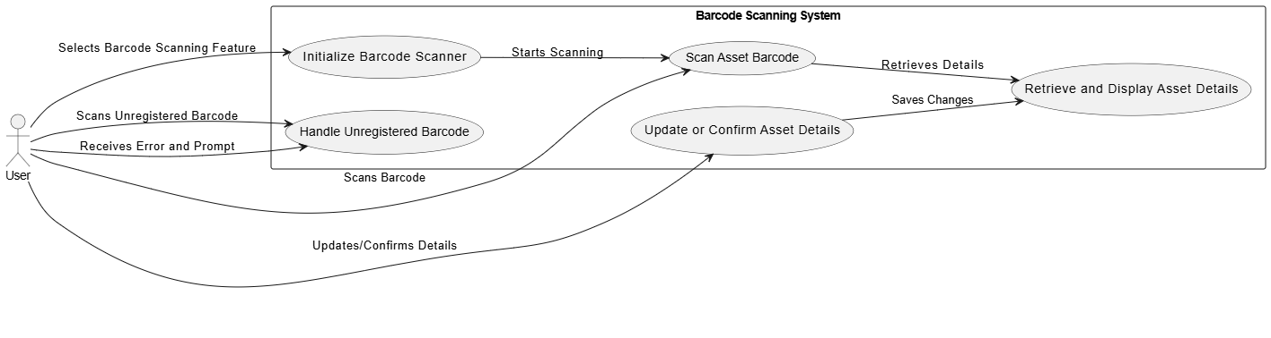

Identifier |  | UC-8
Purpose |  | Allow users to scan barcodes associated with assets for streamlined tracking and management.
Priority |  | Medium
Pre-conditions |  | - User must have access to a barcode scanning device.  - Barcode data must be associated with assets in the system.
Post-conditions |  | - Scanned asset details are updated or retrieved in the system.
Typical Course of Action
S# | Actor Action |  | System Response
1 | User selects the barcode scanning feature. |  | System initializes the barcode scanner interface.
2 | User scans an asset barcode. |  | System retrieves and displays asset details based on the scanned data.
3 | User updates or confirms asset details. |  | System saves changes and updates the asset record.
Alternate Course of Action
S# | Actor Action |  | System Response
1 | User scans an unregistered barcode. |  | System displays an error message and prompts the user to register the asset.

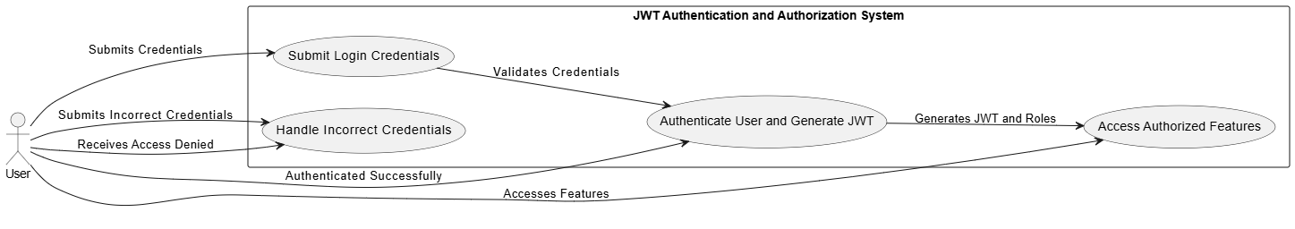
Authenticate and Authorize via JWT
e
Identifier |  | UC-9
Purpose |  | Ensure secure user authentication and authorization using JSON Web Tokens (JWT).
Priority |  | High
Pre-conditions |  | - User must provide valid credentials.
Post-conditions |  | - User is authenticated, and access is granted based on roles and permissions.
Typical Course of Action
S# | Actor Action |  | System Response
1 | User submits login credentials. |  | System validates the credentials.
2 | User is authenticated successfully. |  | System generates a JWT and assigns appropriate access roles.
3 | User accesses authorized system features. |  | System enforces access based on the JWT permissions.
Alternate Course of Action
S# | Actor Action |  | System Response
1 | User submits incorrect credentials. |  | System denies access and prompts the user to retry.

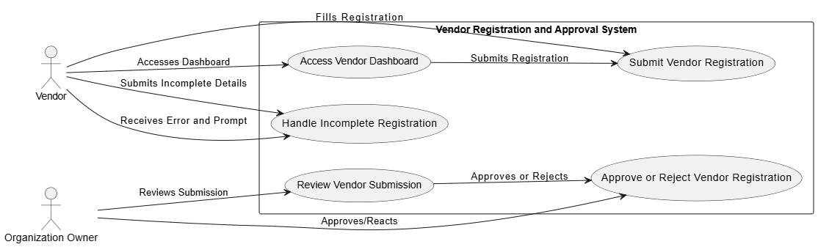
Vendor Registration and Management

Identifier |  | UC-10
Purpose |  | Allow vendors to register and participate in asset-related transactions, while enabling organization owners to manage vendor approvals.
Priority |  | Medium
Pre-conditions |  | - Vendor must be authenticated to access the system.  - Organization owner must be logged in to manage vendor registrations.
Post-conditions |  | - Vendor registration is approved or rejected, and the vendor's status is updated in the system.
Typical Course of Action
S# | Actor Action |  | System Response
1 | Vendor accesses the Vendor Dashboard. |  | System displays the registration form.
2 | Vendor submits registration details. |  | System validates and saves the submission as "Pending Approval."
3 | Organization owner reviews the submission. |  | System displays the vendor’s details for approval or rejection.
4 | Organization owner approves or rejects the registration. |  | System updates the vendor's status and sends a notification.
Alternate Course of Action
S# | Actor Action |  | System Response
1 | Vendor submits incomplete details. |  | System displays an error and prompts the vendor to complete the form.

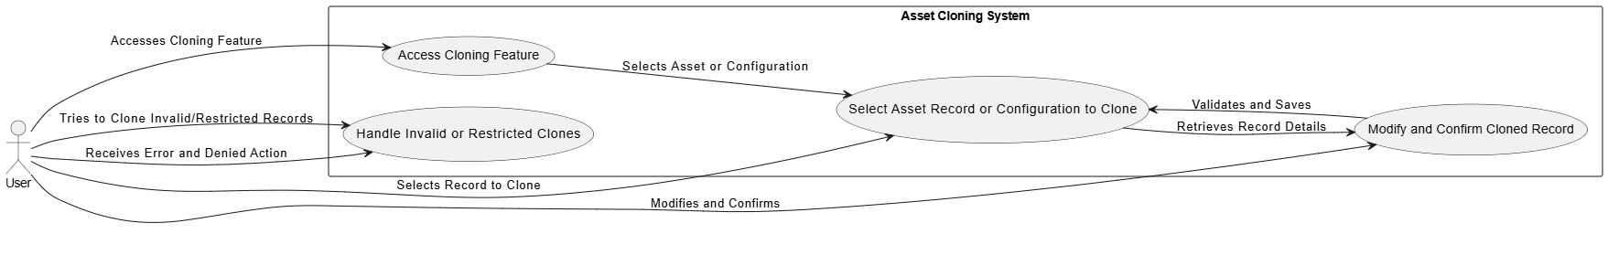
Clone Asset Records or Configurations

Identifier |  | UC-11
Purpose |  | Allow users to duplicate asset records or configurations for efficient bulk asset setup.
Priority |  | Medium
Pre-conditions |  | - User must be logged in with appropriate permissions.  - Existing asset records or configurations must be available.
Post-conditions |  | - New asset records or configurations are created and saved in the system.
Typical Course of Action
S# | Actor Action |  | System Response
1 | User accesses the cloning feature. |  | System displays options to select asset records or configurations.
2 | User selects an asset record or configuration to clone. |  | System retrieves the selected record details.
3 | User modifies cloned details if needed and confirms. |  | System validates and saves the new record.
Alternate Course of Action
S# | Actor Action |  | System Response
1 | User tries to clone invalid or restricted records. |  | System denies the action and displays an error message.

Requirements Analysis and Modeling

Entity-Relationship Diagram (ERD):

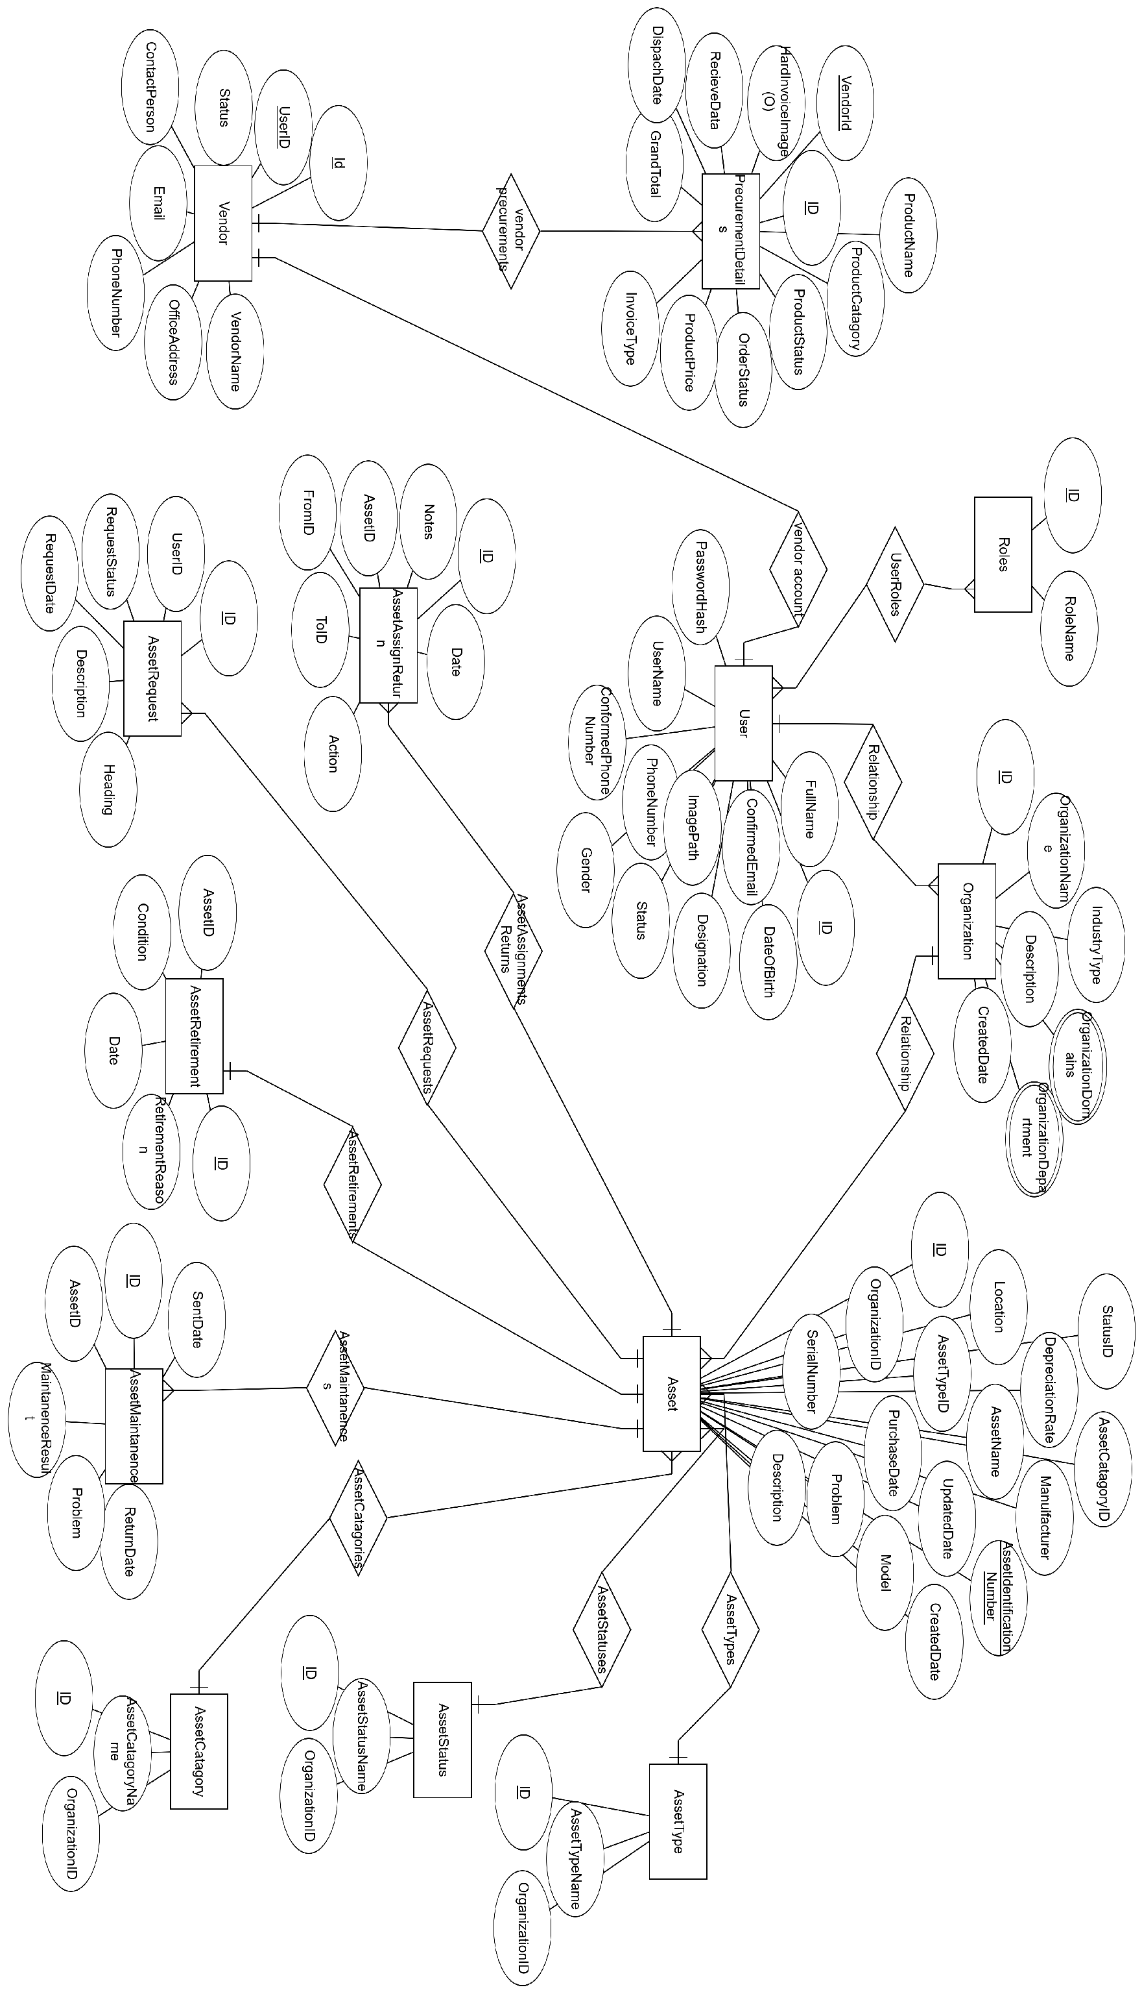

Class Diagrams:

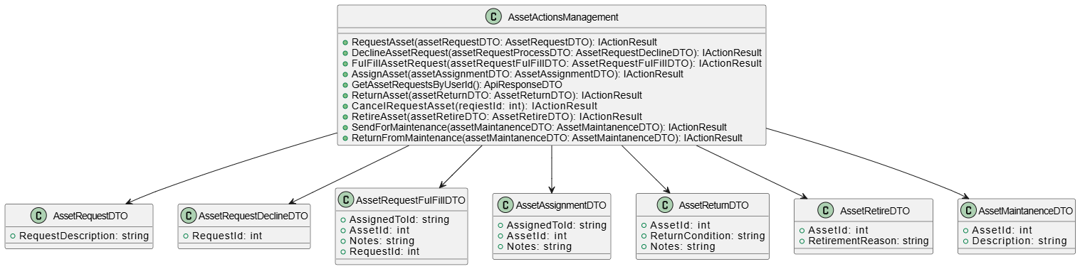
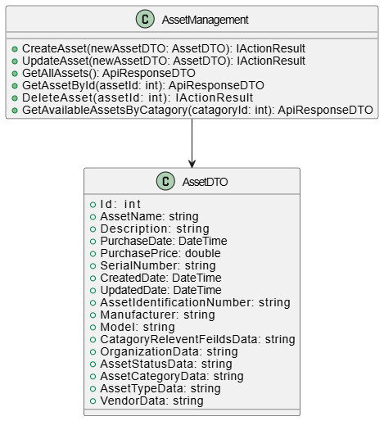

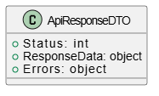

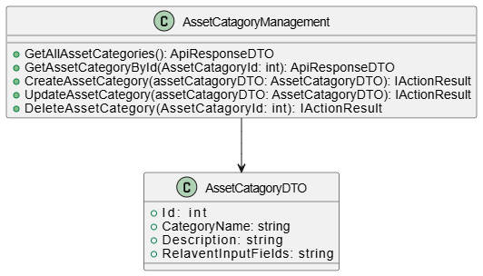

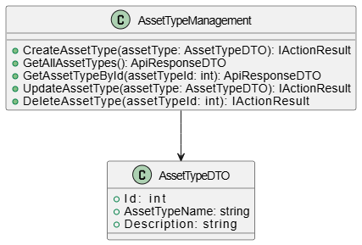

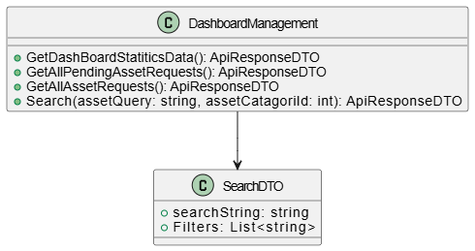

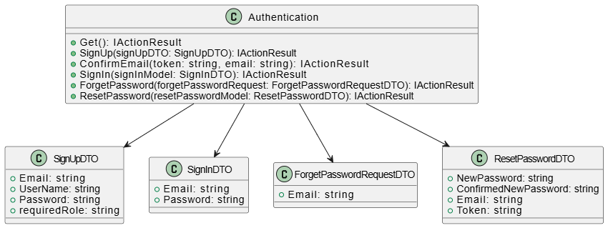

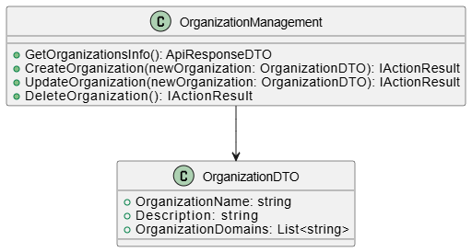

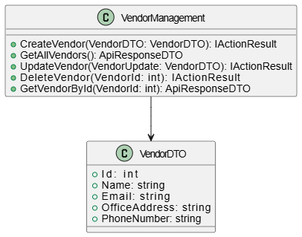

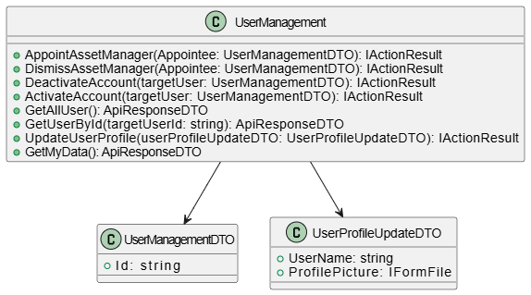

Sequence Diagrams:

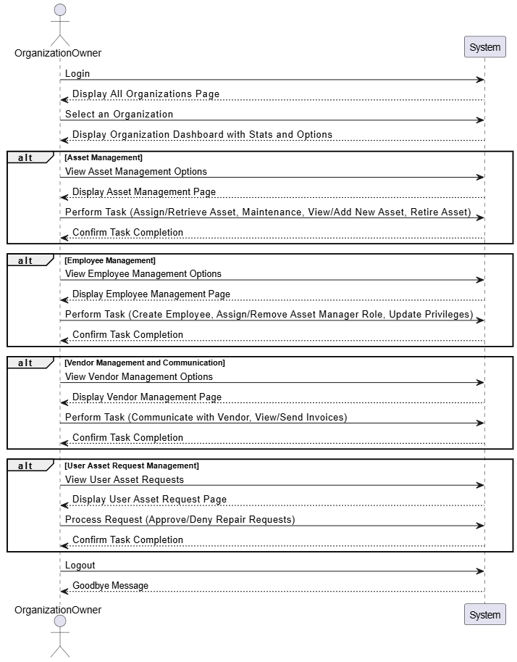

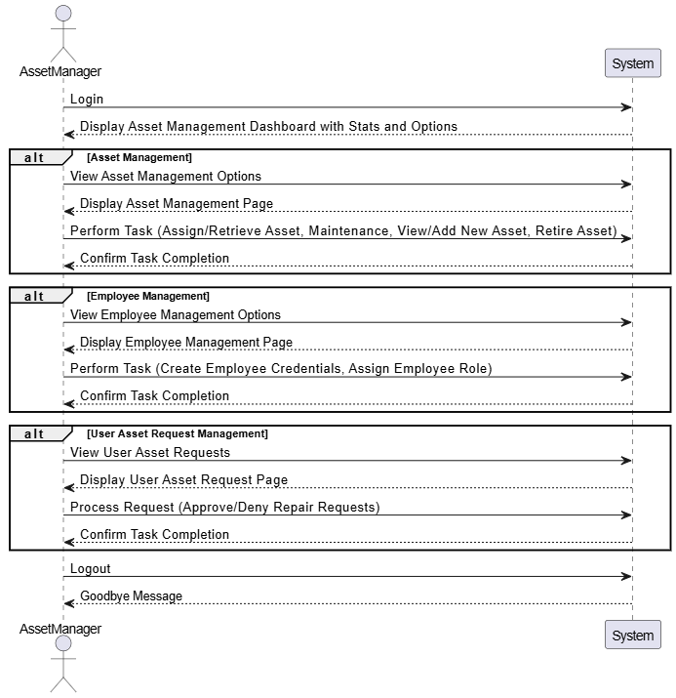

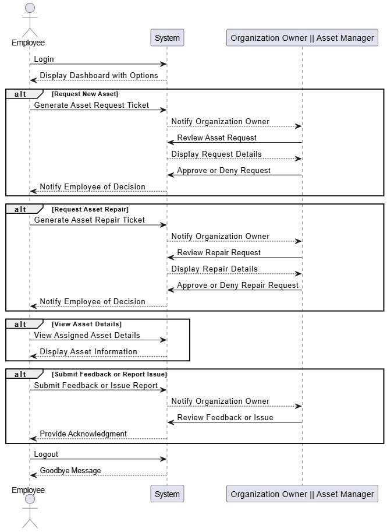
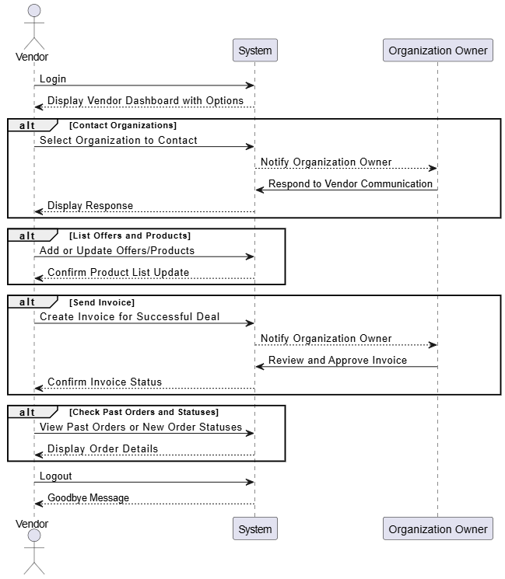

Data Flow Diagram:
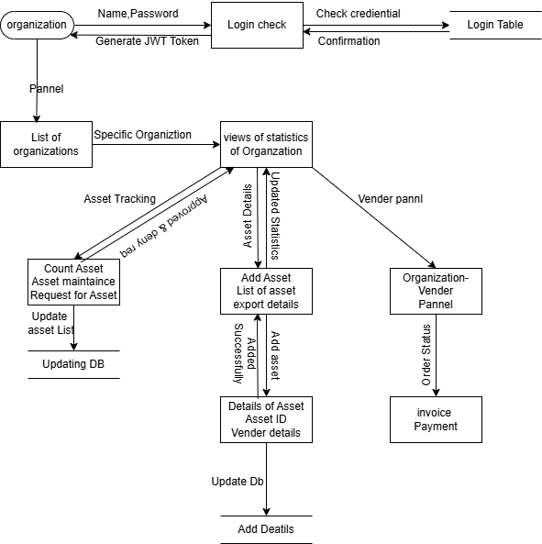

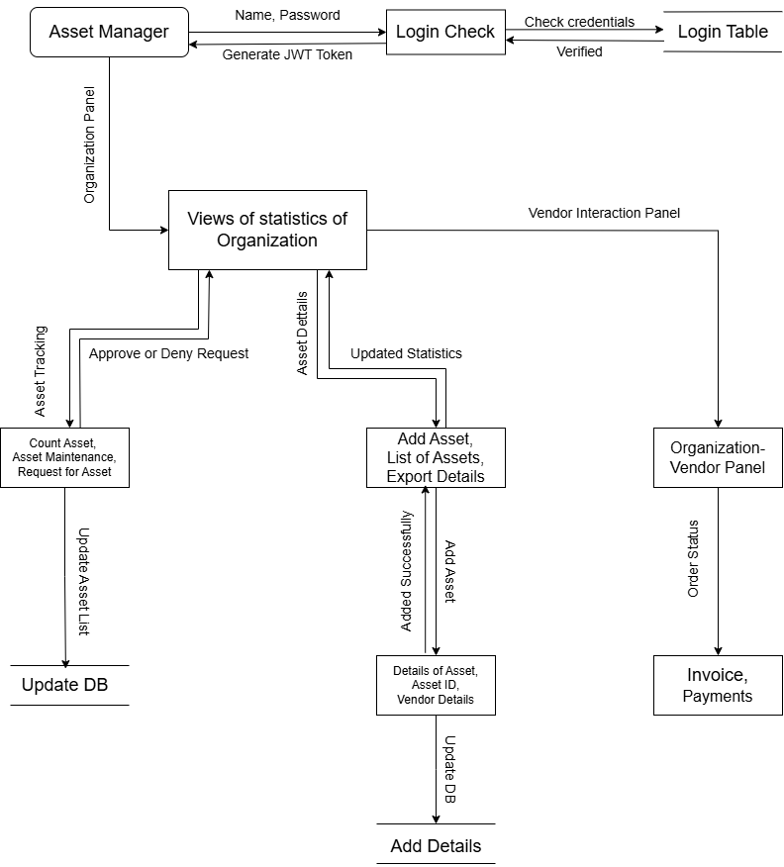

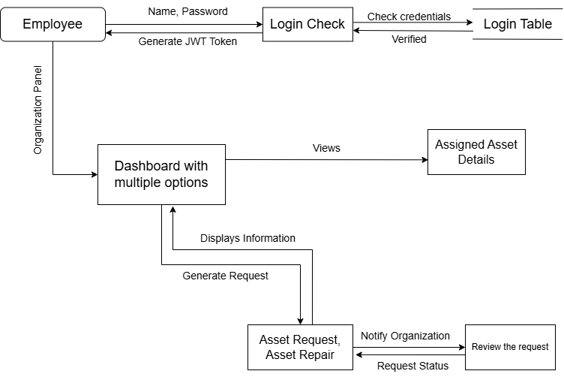

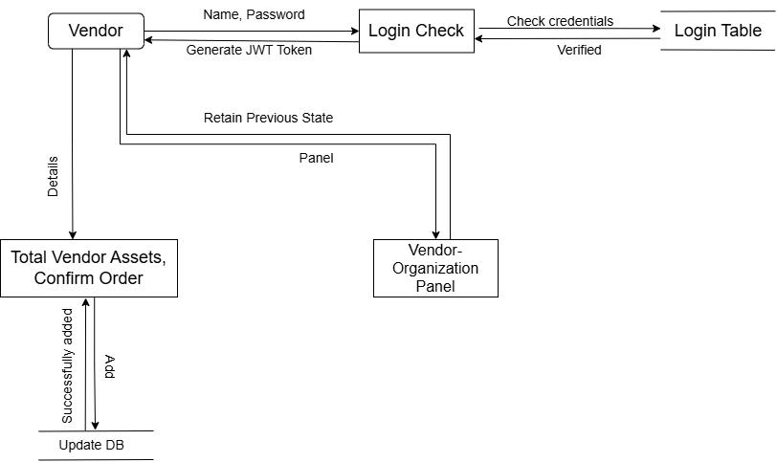

Nonfunctional Requirements

Performance Requirements
The performance requirements for AssetIn aim to ensure optimal functionality under various circumstances while providing a seamless experience for all users. These requirements address system responsiveness, scalability, and resource utilization to guide developers in making informed design choices.
System Responsiveness
- The system must respond to user actions (e.g., navigation, form submissions, and search queries) within 3 seconds under normal operating conditions.
- For resource-intensive tasks, such as generating reports or processing batch updates, operations should complete within 6 seconds for datasets under 10,000 records.
Scalability
- The platform must handle at least 500 concurrent users during peak usage without significant performance issues.
- It should dynamically scale to support up to 10,000 concurrent users using additional hardware or cloud resources as needed.
Database Query Efficiency
- Simple queries, such as retrieving asset details or generating reports, must execute within 2 seconds for datasets containing up to 50,000 records.
- More complex operations, like joins or filtered searches, should complete within 3 seconds for datasets of up to 100,000 records.
Media Retrieval
Media files (e.g., images or documents) stored in the cloud must be retrieved and displayed within 3 seconds for files smaller than 5 MB.
Real-Time Features
Real-time updates, such as asset tracking, must have a latency of no more than 2 seconds for assets within the same network environment.
Functional Features Performance
- Asset Tracking: Asset statuses and locations must update in real time, with a maximum delay of 2 seconds for updates by managers.
- Search and Filter: Results for datasets up to 50,000 records should display within 3 seconds, while datasets up to 100,000 records must display results within 6 seconds.
- Report Generation: Detailed reports must generate within 10 seconds for datasets up to 100,000 records and optimize for download within 16 seconds for datasets as large as 1 million records.
- Maintenance Scheduling: Scheduling maintenance operations, including stakeholder notifications, should complete within 3 seconds.
- Barcode Scanning: Scanning and updating asset information via barcode must complete within 2 seconds after scanning.

Safety Requirements
The safety requirements for AssetIn aim to prevent harm, damage, or loss during its use, ensuring robust safeguards, regulatory compliance, and effective risk mitigation.
Data Integrity and Protection
The system will automatically back up critical asset data, such as location, status, media files, and user logs, at least once every 24 hours, securely storing the backups on a redundant cloud infrastructure. In the event of system updates or maintenance tasks, rollback mechanisms will be implemented to preserve data integrity, allowing the system to restore itself to a stable state in case of failure.
Access Control and Security
Role-based access control (RBAC) will ensure that only authorized roles can access sensitive actions and data. For instance, organization owners will be the only ones able to approve user requests, and asset managers will be responsible for updating asset statuses. Additionally, user authentication will be secured using JWT tokens to prevent unauthorized API usage or impersonation. To further enhance security, user sessions will automatically expire after 15 minutes of inactivity, reducing the risk of unauthorized access.
Error Handling and Recovery
The system will gracefully handle errors such as failed database queries or API calls, providing users with clear error messages without exposing sensitive system details. In case of failed operations, such as barcode scans or report generation, a recovery process will automatically retry the task or allow users to resume the operation without losing data.
Asset Management Safeguards
To avoid asset mismanagement, the system will prevent the deletion of active assets or categories that are linked to ongoing tasks, maintenance schedules, or requests. Before deletion can proceed, users will be prompted to resolve any dependencies. Additionally, input validation will be incorporated across all forms and data entry points to prevent SQL injection and cross-site scripting (XSS) attacks. All data transmissions, including login credentials and asset-related media, will be encrypted using SSL/TLS.
Compliance and Regulatory Standards
If the system is used in healthcare-related industries, it will comply with HIPAA (Health Insurance Portability and Accountability Act) to ensure the security of asset data tied to patient care. The cloud infrastructure used for storing media files will meet ISO/IEC 27001 standards for information security management and adhere to SOC 2 Type II standards for secure cloud operations. Asset-related notifications, such as those for maintenance or transfers, will be sent on time to prevent operational downtime or asset damage due to neglect.

Preventative Measures
The system will ensure that only authorized roles, such as organization owners or asset managers, can perform critical actions, including approving requests, updating asset statuses, or scheduling maintenance. Detailed audit logs will be maintained to track critical operations, enabling the monitoring and investigation of potential misuse. Scalability measures will be in place to dynamically allocate resources during peak usage, preventing system crashes or data loss. Additionally, rate limiting will be implemented to safeguard APIs from overuse or denial-of-service attacks. Critical system settings and configurations will be protected from changes during operational periods, such as ongoing maintenance or procurement cycles.
Safety-Critical Features
The system will include a disaster recovery plan to restore functionality within 4 hours in the event of a critical system failure or data breach. A secondary cloud region will be maintained for redundancy and failover support. The system will also warn users when performing potentially risky actions, such as deleting associated records or making significant configuration changes, requiring confirmation before proceeding. Real-time monitoring will detect unusual activity, such as multiple failed login attempts or unexpected data volume changes, and alert system administrators, allowing for quick responses to potential threats.

Security Requirements
The security and privacy requirements for AssetIn are designed to protect user data, maintain system integrity, and ensure compliance with relevant regulations. These requirements outline key measures to prevent unauthorized access, guarantee data confidentiality, and safeguard sensitive information.
User Authentication and Authorization
The system will implement Role-Based Access Control (RBAC) to restrict access to features based on user roles, such as organization owners and asset managers. JWT-based authentication will be used for secure session management, with sessions automatically expiring after 15 minutes of inactivity to prevent unauthorized access.
Data Encryption
To secure data transmission, all communications will be protected using SSL/TLS encryption. Additionally, user passwords will be stored as hashed values using bcrypt to prevent unauthorized access to sensitive credentials.
Audit Logging
Key actions within the system, such as logins, updates, and approvals, will be logged with timestamps. These logs will assist in debugging and monitoring system activity to ensure accountability.
Error Handling
The system will display generic error messages in the event of failures, ensuring that no sensitive system details are exposed to the users, thereby protecting the integrity of the application.
Data Collection and Control
Only necessary data will be collected, and users will have the ability to update their personal details (e.g., email addresses and passwords). Organization owners will be responsible for managing user accounts and organizational data to ensure proper access control.
Anonymization
To maintain user privacy, sensitive information will be anonymized in reports or analytics, ensuring that personally identifiable information is not exposed in non-essential contexts.
User Identity Authentication Requirements
The login system will validate user credentials against hashed records and limit login attempts to 5 failed attempts within 15 minutes to protect against brute force attacks. Additionally, a secure email-based password reset process will be provided for users to recover their accounts if necessary.
Backup and Recovery
The system will perform daily backups of critical data and provide recovery options in the event of data loss. This ensures business continuity and prevents data corruption or loss.
Validation and Prevention
The system will prevent unauthorized or risky actions, such as the deletion of active assets, by requiring user confirmation for critical tasks. This safeguard will help prevent accidental or malicious actions that could compromise data integrity or system functionality.

Revised Project Plan
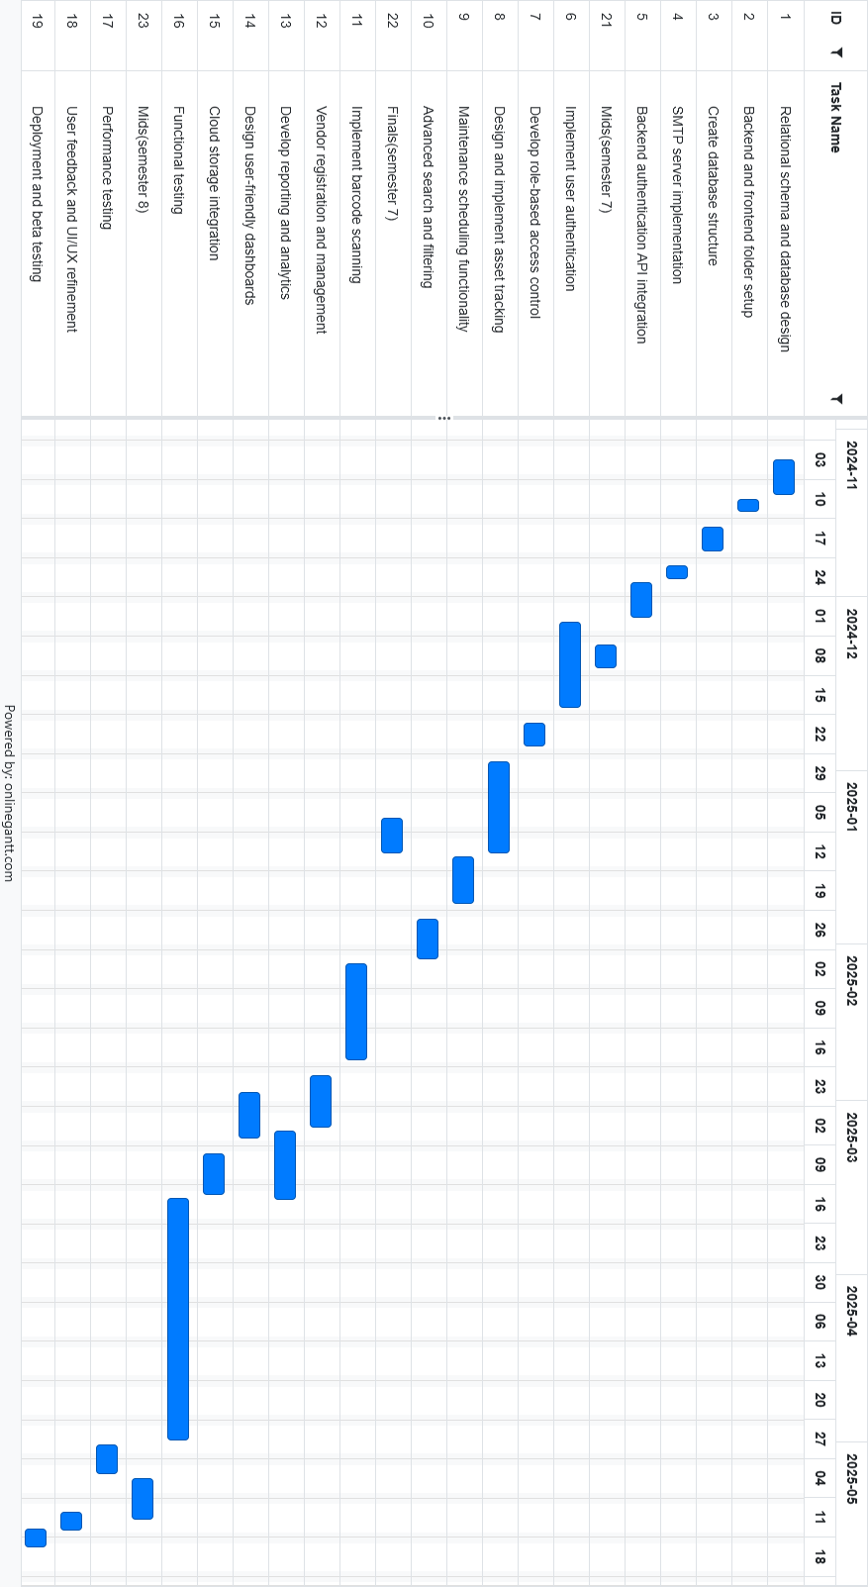
Appendix A: Glossary
General Terms
Asset: Any tangible or intangible resource managed within the system, such as equipment, inventory, software licenses, or intellectual property.
Vendor: A third party or external organization that provides goods or services related to assets, such as repairs, maintenance, or sales.
Role-Based Access Control (RBAC): A security mechanism that restricts system access based on user roles (e.g., Organization Owner, Asset Manager).
Authentication: The process of verifying the identity of a user to grant access to the system.
Authorization: The process of granting or denying access to specific resources or actions based on the user's permissions.
Dashboard: A user interface that displays key metrics, statistics, and actionable insights for managing assets.
Cloud Integration: The use of cloud services to store, retrieve, and manage asset-related media files (e.g., images, videos).
Predictive Analytics: The use of data analysis techniques to forecast asset maintenance needs and optimize performance.
Audit Log: A chronological record of system activities, such as user actions or system changes, used for monitoring and debugging.
API (Application Programming Interface): A set of rules and tools for building software and enabling communication between the backend and frontend or external systems.

Abbreviations and Acronyms

SRS: Software Requirements Specification: A document detailing the functional and nonfunctional requirements of the project.
SMTP: Simple Mail Transfer Protocol: A protocol used to send emails within the system, such as notifications or password reset links.
JWT: JSON Web Token: A compact and secure method for transmitting information between the client and server for authentication and authorization.
SSL/TLS: Secure Sockets Layer / Transport Layer Security: Protocols used to encrypt communications between the client and server.
CRUD: Create, Read, Update, Delete: Basic operations performed on database records.
UI/UX: User Interface / User Experience: The design and experience of interacting with the system.
RBAC: Role-Based Access Control: A security feature that restricts system functionality based on user roles.
GDPR: General Data Protection Regulation: A regulation designed to protect user data privacy (used here for awareness).
AES: Advanced Encryption Standard: A method for securely encrypting sensitive data at rest.

References
[1] “Ralph3 Documentation,” *Ralph3 Official Site*. [Online]. Available: https://ralph3.readthedocs.io/. [Accessed: 20-Jan-2024].
[2] “Snipe-IT Asset Management,” *Snipe-IT Official Documentation*. [Online]. Available: https://snipe-it.readme.io/. [Accessed: 20-Jan-2024].
[3] “Asset Tiger Review,” *Asset Tiger Blog*. [Online]. Available: https://www.assettiger.com/blog/. [Accessed: 19-Jan-2024].
[4] Angular Team, “Angular Documentation,” *Angular*. [Online]. Available: https://angular.io/docs. [Accessed: 18-Jan-2024].
[5] Microsoft, “ASP.NET Core Overview,” *Microsoft Documentation*. [Online]. Available: https://docs.microsoft.com/en-us/aspnet/core/. [Accessed: 18-Jan-2024].
[6] Oracle, “MySQL 8.0 Reference Manual,” *MySQL Official Documentation*. [Online]. Available: https://dev.mysql.com/doc/refman/8.0/en/. [Accessed: 19-Jan-2024].
[7] T. Koller and M. Goedhart, *Valuation: Measuring and Managing the Value of Companies*, 7th ed. Wiley, 2020, pp. 45–67.
[8] J. Smith, “Predictive maintenance in asset management,” *Journal of Engineering Management*, vol. 23, no. 4, pp. 321–333, Dec. 2021.
[9] “General Data Protection Regulation (GDPR),” *European Union*. [Online]. Available: https://gdpr-info.eu/. [Accessed: 18-Jan-2024].
[10] “HIPAA Compliance,” *U.S. Department of Health & Human Services*. [Online]. Available: https://www.hhs.gov/hipaa/index.html. [Accessed: 17-Jan-2024].
[11] ISO/IEC 27001:2013, “Information Security Management Systems,” *International Organization for Standardization*. [Online]. Available: https://www.iso.org/standard/54534.html. [Accessed: 17-Jan-2024].
[12] Postman Team, “Postman API Testing,” *Postman*. [Online]. Available: https://learning.postman.com/docs/writing-scripts/. [Accessed: 19-Jan-2024].
13] Swagger, “Introduction to API Testing,” *Swagger.io*. [Online]. Available: https://swagger.io/docs/. [Accessed: 19-Jan-2024].
Appendix B: IV & V Report
(Independent verification & validation)
IV & V Resource

Name Signature

S# | Defect Description | Origin Stage | Status | Fix Time
 |  |  |  | Hours | Minutes
1
2
3
…
Table 2: List of non-trivial defects

